**EXPERIMENT 1**

**ER DIAGRAM OF COLLEGE DATABASE**

**Aim:** Draw an ER diagram of a college database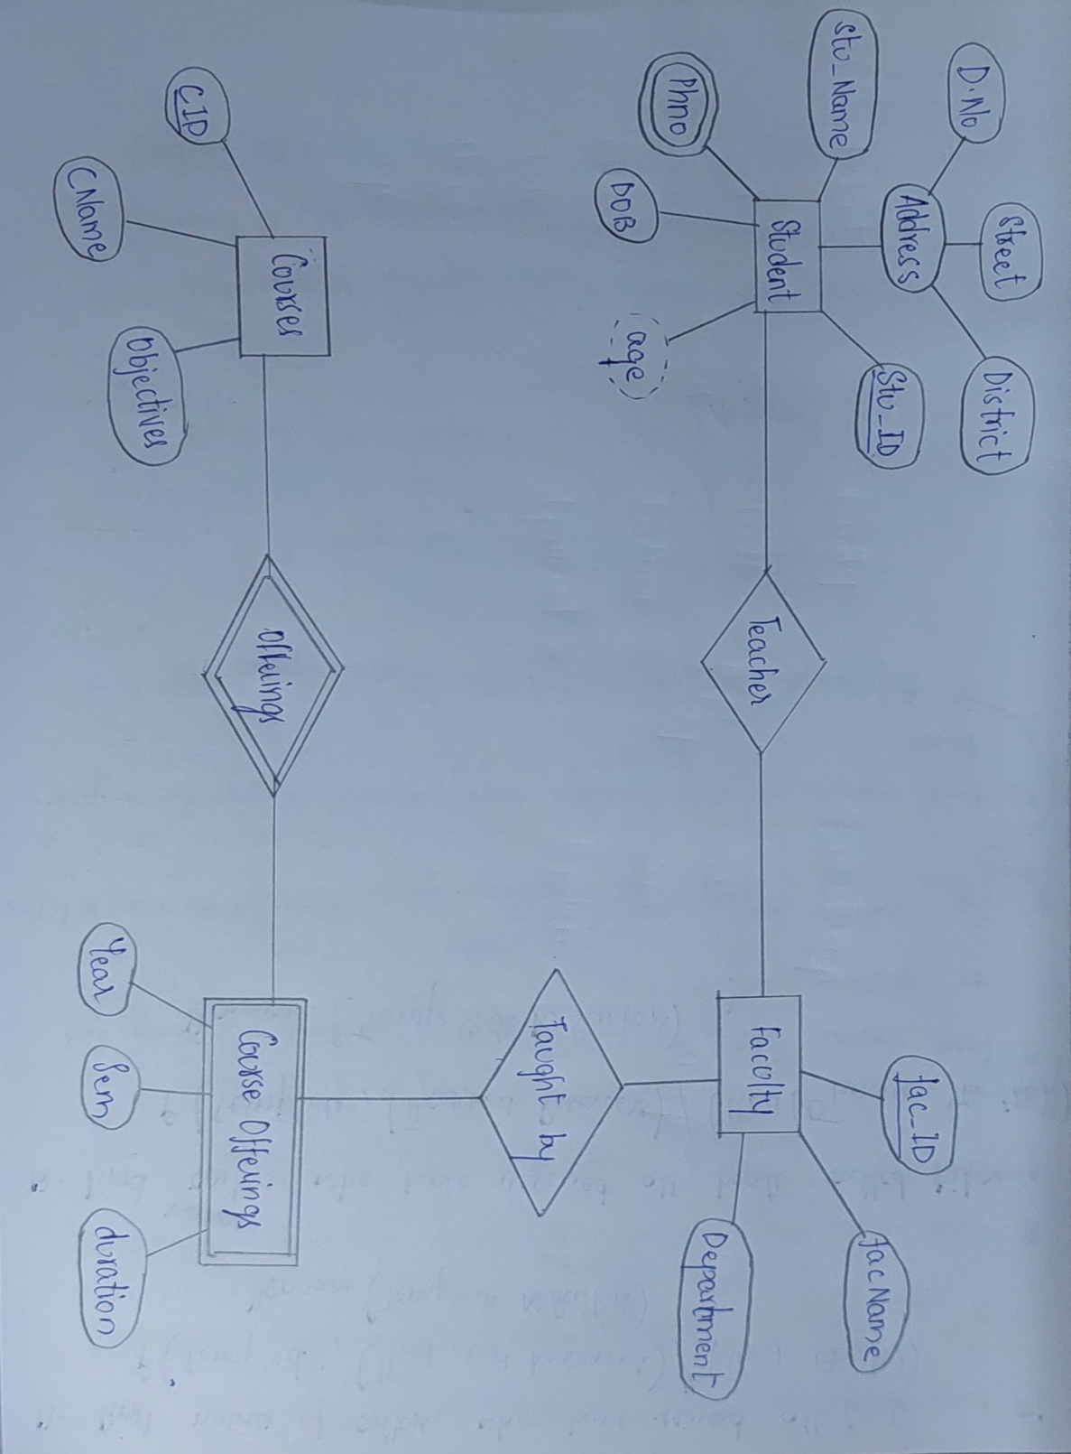

**offerings**

**Course offerings**

**Course**

**Faculty**

**teaches**

**Taught by**

**Student**